Methods S1. Incubation protocol.
Overview: This method leverages cellular respiration to isolate nonstructural carbon from plant tissue. While an approach for wood samples is described here, we have similarly applied this method in coarse root cores, twigs, and leaves for ¹⁴C. We describe the entire methodological procedure, from tree core collection up to collection of respired CO₂. Because subsequent steps (CO₂ purification and graphitization for Accelerator Mass Spectrometry) are well-described in the literature, we simply describe the purpose and main points of these steps, with reference to appropriate sources. Target mass of C for AMS measurement is ~1 mg, and though samples as small as 0.1 mg can be reliably analyzed with robust purification and graphitization procedures, careful attention to leaks and gas contamination (e.g. atmosphere in tubing) becomes essential when analyzing smaller samples.

A note on contamination: To estimate contamination by atmosphere (leaks) and other sources (regulator oils), we combusted modern oxalic acid (OX-II, NIST SRM 4990C) with CuO oxidizer under vacuum in quartz tubes (Boutton et al. 1983). Tubes were then smashed inside previously flushed and sealed jars by vigorous shaking. Gas was then transferred to bags and extracted on the vacuum line and graphite was analyzed by the W.M. Keck AMS facility at UC Irvine. The F¹⁴C of this sample was 1.3345, or about 7‰ lower than a normal OXII (F¹⁴C=1.3407) indicating a small amount of atmospheric carbon remains in jars after flushing (~1%).

Materials:
-Incubation chambers
- 256 mL mason jars (“wide-mouth half-pint” in USA, e.g. https://www.amazon.com/Packs-Ball-Mason-Wide-Mouth/dp/B00T8GCOEM)
- Modified wide-mouth ball jar lids (e.g. https://www.amazon.com/Ball-Jars-Wide-Mouth-Count/dp/B07P9MTFQ2)
- luer lock fittings, Cole-Parmer part numbers are given, note many sizes are available.
- Male-luer to hose barb valves (e.g. Cole-Parmer# EW-45505-04)
- Bulkhead, Female Luer to Hose Barb (e.g. Cole-Parmer# EW-45508-32)
- One-way stopcock, male luer-lock (e.g. Cole-Parmer# EW-30600-00).
- Standard nut to thread onto Female Luer to Hose Barb.
- Elmer's Products E650A Stix-All Cement (Ohio, USA)
- 1/4” Bev-a-aline tubing (Cole-Parmer, Illinois, USA).
-Field sampling and preparation
- oil-free razor blades (can be cleaned with 80% EtOH and allowed to dry).
- oil-free 12mm increment borer (Haglof/Mattson, Sweden). Note, newly purchased borers are lubricated and this lubricant must be removed with EtOH.
- Nitrile gloves
- portable drill press vice (Harbor Freight SKU: 30999).
- [optional] Cooler for transport to lab space; this is only necessary if outside temperature is very different from desired incubation temperature, or if transport time is potentially long (e.g. https://canyoncoolers.com/products/outfitter-22/).
- [optional] hand lens (e.g. https://www.pmsinstrument.com/products/eye-lens-with-lanyard/)
- [optional] portable light source, a headlamp is convenient.

-Consumables
- 80% EtOH for cleaning (diluted from absolute or HPLC grade)
- CO₂-free air (such as UltraZero air, AirGas; composition: 20-22% oxygen, 78-80% nitrogen, <1 ppm CO₂ + CO) with a two-stage regulator; note that this mixture must include oxygen to support aerobic respiration of tree tissues during incubations.
-For gas sample collection
- Infrared Gas analyzer for CO₂ concentration (e.g. LiCor 6262 or LiCor 800-series) [optional]
- 1L gas stabilizer can (LabCommerce, CA, USA; X31L-1004) [optional]
- [Optional, not recommended]: Zeolite molecular sieve traps (e.g. Hardie et al. 2005). These are not preferred due to unavoidable carryover or “memory” effects between samples upon repeat use.
- 1L Tedlar gas bag with two valve ports (Keika ventures, NC, USA; # TB-01LPoly2in1)
- 5 mL gas syringe (ColeParmer, Ohio, USA) [optional]
- ¹⁴C standards (Oxalic acid II) [optional]
- Either (1) a way to ship gas samples (e.g. gas stabilizer cans, zeolite traps) or (2) access to isotope prep facilities, including CO₂ purification line and graphitization line.

Procedure:
- Preparation to avoid contamination with dead carbon (∆¹⁴C << 0)
  - Jars can be washed with ethanol (80%) and oven-dried overnight.
  - Razor blades and increment borers should be oil-free. Note that increment borers are typically delivered from the manufacturer coated in a lubricant, including the interior of the borer; this lubricant contains dead carbon which will contaminate samples if not removed. Borers can be cleaned by repeatedly pushing cloth soaked in ethanol through the interior of the borer, follow by oven drying. If desired, borer can be subsequently rinsed with deionized water, though this may risk rusting of the borer.
  - Construction of chamber lids should be conducted to have no exposed glue within the chambers (see B).
    - Note that some glues will volatilize dead carbon indefinitely, even after curing. This can be tested by allowing cured glue to sit in a sealed chamber, along with sealed pyrex tube of CO₂ from a known radiocarbon standard (e.g. OX-II). Smash the tube inside the jar, analyze the resulting CO₂ (see F-H), and assess the background contamination.
- Construction of chamber lids.
  - Ball jar lids can be modified to allow two ports, each with a luer-lock stopcock on a bulkhead fitting, attached through a drilled hole in the lid (to match female Luer to hose barb bulkhead fitting), and tightened on to the inside; see Image S1. Two ports are necessary to allow for flushing and sample collection.
  - Bulkhead fittings can be additionally sealed only on the outside/top of the lids with silicone caulking/hot glue/etc. In this way there is no exposed glue inside the chamber. It is best to test the glue used does not continue to volatilize after curing as described in A.
    - We used Elmer's Products E650A Stix-All Cement (Elmer’s, Ohio USA), but manufacturer formulations and availability can change. Generic hot glue is another option for this sealing step (e.g. https://www.amazon.com/Gorilla-8401509-Hot-Glue-Sticks/dp/B07K791YRP), but formulations may vary and so should be tested for contamination.
- Field sampling – Time from tree coring to incubation initiation (D.3) should be minimized; in our work we keep this to <30 minutes. Depending on subsampling, this can be challenging, use of cold-rooms and/or previously cross-dated cores (C.3.i) is advised if this processing time will be much longer. In addition to losing respired CO₂ during this processing time, samples are dehydrating, further limiting ultimate respiration totals.
  - Collect an increment core from the target tree.
    - Note that if sampling multiple trees, cleaning the borer with ethanol between trees will contaminate samples and is not advised (ethanol mixes with tree residues inside the borer and does not rapidly evaporate).
    - If contamination of xylem with phloem sap is a concern, bark sample could be collected separately with a punch slightly larger than the increment borer (i.e. 13 mm), and increment core could subsequently be collected within this hole.
  - Wearing gloves, remove the core and mount on vice, where contact surfaces are covered with plastic film or similar (a spare glove can also be used, which is easy to replace if processing multiple cores). Core should be mounted with rings vertically oriented.
  - Surface the core in a single cut with a very sharp razor blade so ring boundaries are clearly visible. A hand lens and light source can be useful to see ring boundaries in the field; lighting the core surface at a shallow angle will often reflect ring boundaries clearly.
    - If tree rings are narrow, it may be useful to compare to a previously collected and crossdated tree core processed according to standard methods (Fritts and Swetnam 1989).
  - To sub-sample the sapwood, remove from the vice and slice directly on ring boundaries with a very sharp razor blade. Immediately proceed to D.
    - In selecting sub-samples, it is important to account for the expected production of respired CO₂, which may vary with species, tissue, etc.; the target for AMS measurement is around 1 mg.
  - If also measuring nonstructural carbon concentrations, a replicate core can be collected and flash frozen in the field on dry ice. This can be sectioned first, or later after drying. Note that razor surfacing of this core is preferred, as sanding moves material across ring boundaries, effectively “smearing” isotopic or concentration patterns across rings.
- Incubation – Goal is to isolate respired CO₂.
  - Immediately place sapwood sub-sample in a sealed mason jar with two-port lid.
    - Note that these lids will leak under high pressure; this needs to be considered in both sampling (e.g. transporting incubations to a very different elevation) and gas collection (avoid pressurizing jars; i.e. cannot pull directly onto the vacuum line).
  - Flush the jar with both chamber stopcocks open with UltraZero air (important: contains ~20% oxygen to allow respiration) to remove all CO₂ from the jar.
    - Flushing gas pressure and time should be calibrated to flush through ~10 times the chamber volume of flushing gas. Pressure should not be so high as to stress lid fittings which may subsequently cause leaks.
Alternatively, chamber headspace air can be scrubbed of atmospheric CO₂ with a soda-lime column (such as from a LiCor 6400) inline and a pump and IRGA assembly (such as the Flux Puppy system Carbone et al., 2019) to monitor/verify removal of CO₂.
  - Seal the jar by rapidly (and gently) closing the stopcocks.
  - Move sealed jar to a cooler and transport quickly to a lab space and allow incubations to proceed for 120 hours (5 days).
    - Note: cooler is not for chilling the samples, only to avoid temperature extremes (e.g. direct sun or freezing temperatures in the back of a truck) that are very different from the lab space.
    - Note: If incubating samples with photosynthetic tissue (i.e. green bark), incubations should take place in the dark (i.e. within the cooler).
- Sample headspace air for CO₂ concentration.
  - Fit a 5 mL syringe with a one-way stopcock, male luer-lock fitting.
  - Flush syringe three times with nitrogen gas (or other CO₂ free gas).
  - Collect 5 ml gas sample from the jar through one of the ports.
  - Run the 5 mL gas sample on an IRGA, such as a LiCor 6262 or LiCor 800-series, and compare to a calibration curve constructed from standard gases of known concentrations.
    - Example calibration curve: 201, 380, 2070, 4000, 10000, 50000 ppm CO₂
  - Note that while this only represents ~ 2% of the headspace, for small samples this should be avoided and CO₂ concentration can be quantified on the vacuum line in G.
- Collect headspace air – many methods are possible, we describe our preferred protocol. Note: Pulling directly from the jar into a 1L stabilizer can will cause the jar lid to leak, contaminating the sample and damaging the lid.
  - Fill a 1L Tedlar gas bag with nitrogen (or other CO₂ free gas)
  - Attach filled bag to one jar lid port and open bag valve.
  - Attach evacuated can to second jar lid port.
  - Open both lid port stopcocks, then open stabilizer can valve, allowing the nitrogen to flush from the bag, through the jar, and into the can. Proceed to G.
  - Freeze and then oven-dry, or freeze-dry the sapwood subsample to obtain a dry mass for normalizing respiration rate. This sample can also be ground and analyzed for post-incubation NSC concentrations.
Note G and H are shared with the extraction method, and are standard preparatory steps for radiocarbon measurement. They are roughly described here to give a familiarity with the entire procedure.
- Purify gas sample from bag or can cryogenically on a vacuum line: Briefly, the gas sample is vacuumed out onto a vacuum line, passed sequentially through a trap (‘cold-finger’) that freezes out any water (ethanol-liquid nitrogen slurry) and a trap which freezes out CO₂ (liquid nitrogen). After the rest of the sample is vacuumed away, purified CO₂ can be measured by pressure within a line section of known volume, and subsequently sealed in a pyrex tube (e.g. Bertolini et al. 2005, Fig. 1).
- Graphitize the CO₂ sample. This is well described in (Lowe 1984, Vogel et al. 1984). Briefly, the CO₂ sample is reduced by hydrogen gas in the presence of iron and magnesium perchlorate (to absorb water) at high temperature (400C) to produce graphite. This graphite is subsequently pressed into an aluminum target, and analyzed on an AMS such as a MICADAS (Synal et al. 2007) for ¹⁴C content. Relevant calculations of ∆¹⁴C and age estimation by comparison to the bomb-spike are described in the main text.

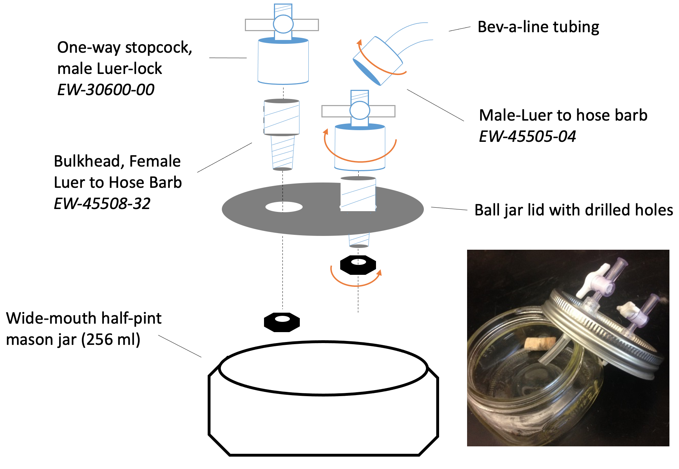
Image S1. Assembly of two-port lids. Glue can be applied to the area around the top of the female bulkhead valve, including the threaded connection. Glue should not be applied on the inside of the lid (bottom side). Additional bev-a-line tubing section in inset image can be added to underside of lid improve efficiency of headspace flushing (Procedure D.2).

References
Bertolini T, Rubino M, Lubritto C, D’Onofrio A, Marzaioli F, Passariello I, Terrasi F (2005) Optimized sample preparation for isotopic analyses of CO2 in air: systematic study of precision and accuracy dependence on driving variables during CO2 purification process. J Mass Spectrom 40:1104–1108.
Boutton TW, Wong WW, Hachey DL, Lee LS, Cabrera MP, Klein PD (1983) Comparison of quartz and pyrex tubes for combustion of organic samples for stable carbon isotope analysis. Anal Chem 55:1832–1833.
Carbone MS, Seyednasrollah B, Rademacher TT, Basler D, Le Moine JM, Beals S, Beasley J, Greene A, Kelroy J, Richardson AD (2019) Flux Puppy–An open-source software application and portable system design for low-cost manual measurements of CO2 and H2O fluxes. Agric For Meteorol 274:1–6.
Fritts HC, Swetnam TW (1989) Dendroecology: A tool for evaluating. Adv Ecol Res 19:111–188.
Hardie SML, Garnett MH, Fallick AE, Rowland AP, Ostle NJ (2005) Carbon dioxide capture using a zeolite molecular sieve sampling system for isotopic studies (13 C and 14 C) of respiration. Radiocarbon 47:441–451.
Lowe DC (1984) Preparation of graphite targets for radiocarbon dating by tandem accelarator mass spectrometer (TAMS). Int J Appl Radiat Isot 35:349–352.
Synal H-A, Stocker M, Suter M (2007) MICADAS: A new compact radiocarbon AMS system. Nucl Instrum Methods Phys Res Sect B Beam Interact Mater At 259:7–13.
Vogel JS, Southon JR, Nelson DE, Brown TA (1984) Performance of catalytically condensed carbon for use in accelerator mass spectrometry. Nucl Instrum Methods Phys Res Sect B Beam Interact Mater At 5:289–293.

